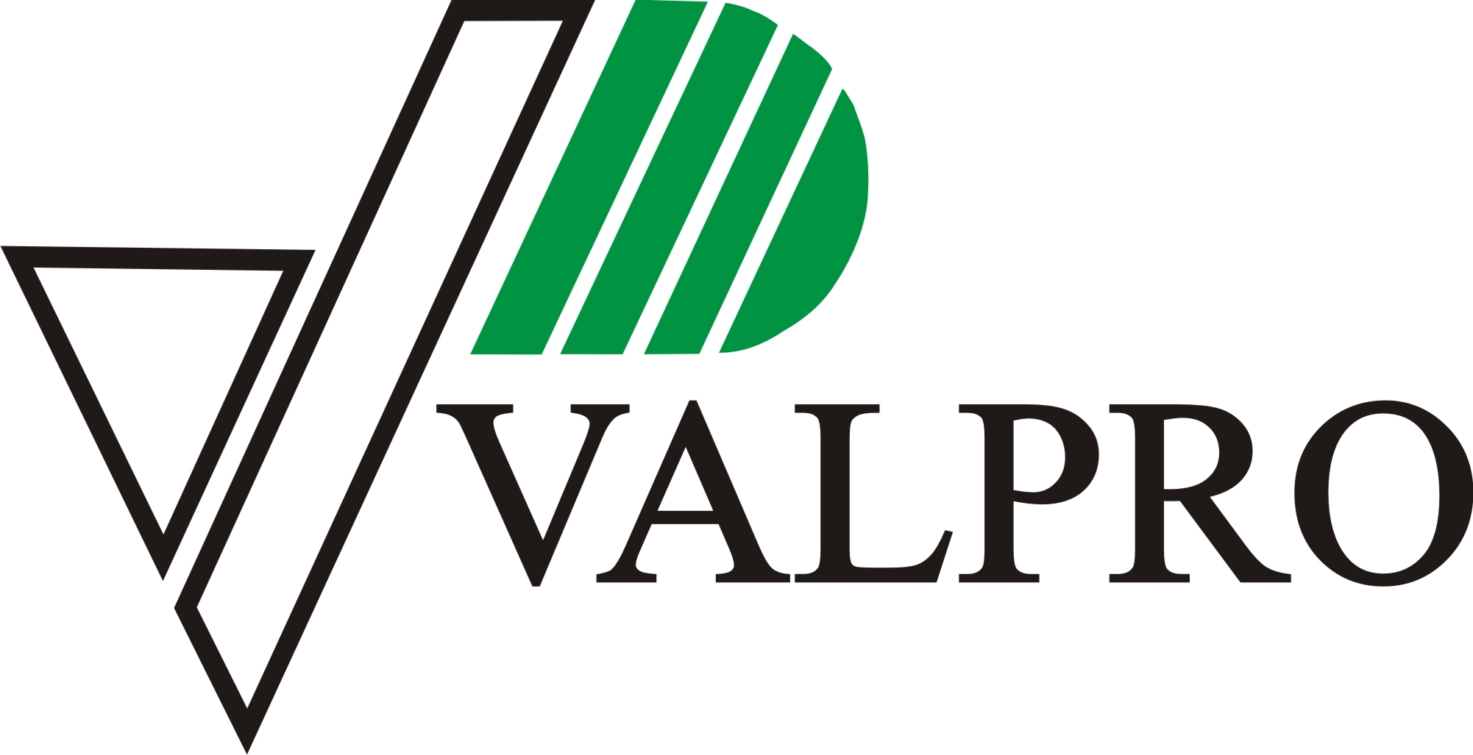
VALPRO Ltd. FORM FOR NEW PRODUCT DESIGN
GENERAL INFORMATION
Cylinder usage environment or an aim of use:
Fire extinguisher
Fire extinguisher systems
Other:

Target price, EUR:

Forecast of required order amount, pcs:
Per batch
Per month
Per year

Delivery address: *to calculate delivery costs
Preferred time for project start-up: *week/year

TECHNICAL PARAMETERS
Extinguishing agent:
kg
L
Other:

Exact cylinder volume: litres
Cylinder material:
Carbon steel
Stainless steel

Cylinder type:
With internal coating (PLASCOAT)
Without internal coating

Cylinder design:
2-part cylinder (only applicable for carbon steel)
3-part cylinder

Cylinder surface treatment:
RAL 3000, 70 microns
Additional surface treatment:
Other colour:

Cylinder diameter:

- 2-part cylinder (mm):
80 | 90 | 110 | 112 | 125 | 150 | 160 | 180 | 185 | 190

- 3-part cylinder (mm):
110 | 140 | 150 | 160 | 170 | 180 | 185 | 190 | 245 | 293 | 306

- Type of cylinder for automatic extinguisher (diameter 293 mm):
6 | 9 | 12

- Other*:

*Other designs and manufacture of equipment are available based on customer needs. For more detailed information please contact sales manager.

Neck type:
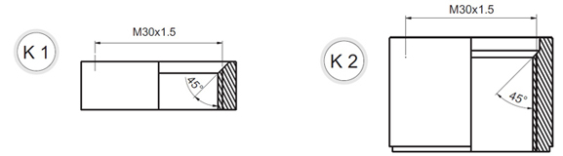  For powder cylinders (St37/St52 DIN 1629) |  | For powder cylinders (St37/St52 DIN 1629)
For foam-water cylinders (AISI 316L/DIN EN 1.4435)  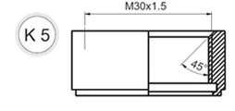 |  |   For powder and foam cylinders (St37/St52 DIN 1629)

Other type neck (M45 x 1,5, G½”; G1”; G1½”; G2”; 1”-14-UNS etc.):

Neck top part:
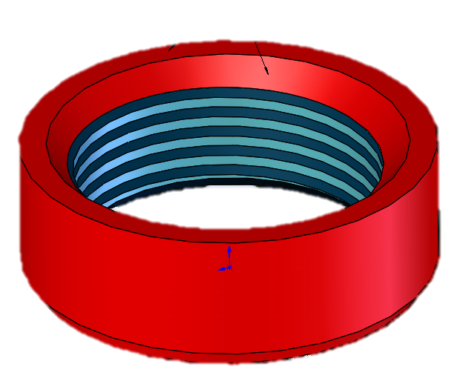  With painting  With painting |  | Without painting  Without painting  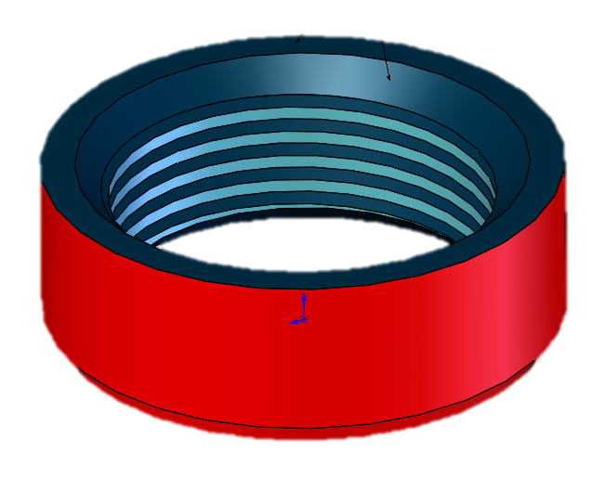

Bottom type (please choose preferred version and we will specify options):
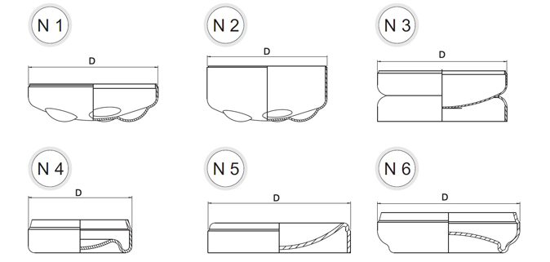  ∅90 - ∅190 | ∅90 - ∅190 | ∅140 - ∅306
∅80 | ∅110; ∅125 | ∅160; ∅170;  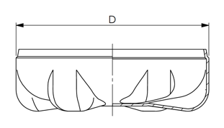

Cylinder clamps:
Clamp for wall bracket
Clamp for hose holder
None
Other:

Valve positioning:
do not needed
needed*, valve torque Nm

* If needed, VALPRO must receive 10 pcs. of O-rings and 3 pcs. of valves in order to set correct positioning

Maximum allowable working pressure PS bars (VALPRO standard is 20 bars)

Other requirements, which have not been mentioned above:

Please enclose additional information in attachment (photos, drawings etc.).

According to the information given in this form we will prepare and send you approximate price offer. If additional drawing is required, price and process shall be discussed individually. Each case is viewed and evaluated separately.

Company: Representatives’ name, surname: Position: Signature: Date:

